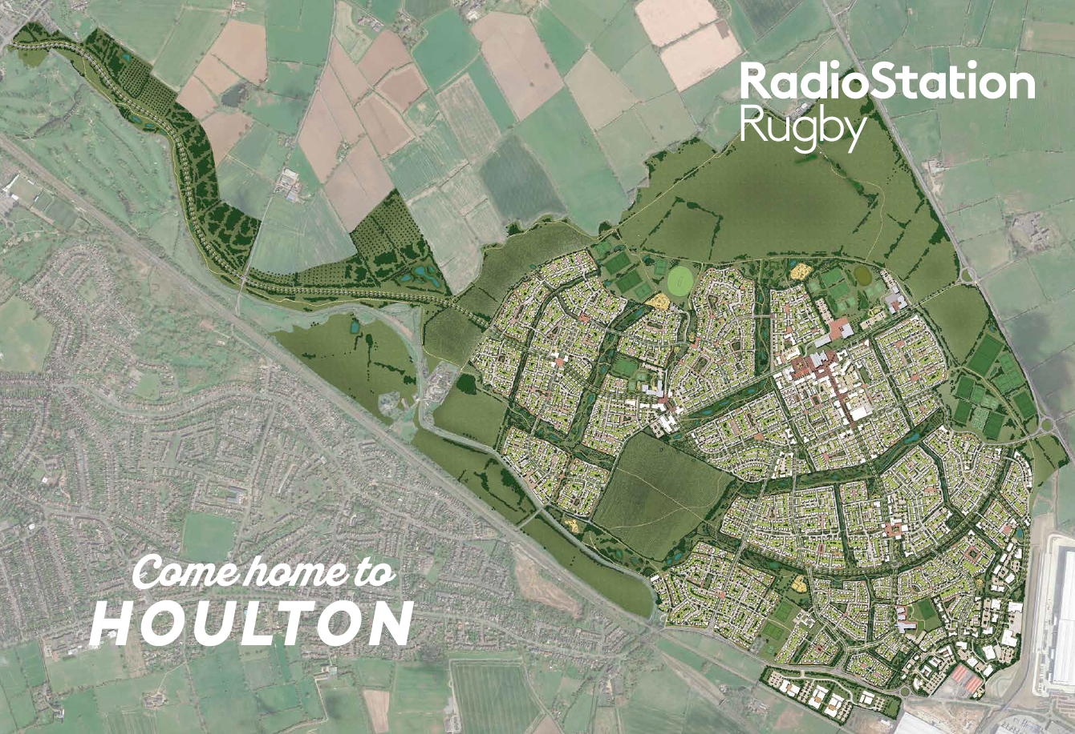

Background
RadioStation Rugby is a joint venture between developer Urban&Civic and Aviva Investors and will see 453 hectares of land on the east of Rugby, transformed into a 6,200 home urban extension over the next 15-20 years.
Houlton, the first phase of this bigger picture, has now begun.
The long-term vision for the development is to create a thriving community of homes, schools, shops and fantastic transport connections, nestled amongst acres of open space and stunning Warwickshire countryside.
Useful links
www.houltonrugby.co.uk / www.urbanandcivic.com / www.theoldmastsiterugby.co.uk
For more information
Johanne Thomas, Urban&Civic, Johanne.thomas@urbanandcivic.com / 07469 150 290

Working with us
We have opportunities for you to join the Urban&Civic team at RadioStation Rugby and be part of the transformation of this exciting site.
The roles are flexible and we would be keen to hear from people who think they have the skills, experience and drive to play a part in the creation of Houlton.
To apply, submit your CV to Johanne.thomas@urbanandcivic.com stating the job title for the role
Opportunities

Visitor Centre Manager
You’ll manage the facilities on offer at our Dollman Farm courtyard hub, managing the day to day operations, organisation and community liaison.
You’ll be based in our Visitor Centre and have a public facing role, communicating the vision for the future at Houlton. The role requires flexibility and adaptability as Dollman Farm grows.
Responsibilities
- Running the sitewide Visitor Centre/marketing suite to support members of the public as they visit and ensure the centre operates efficiently. You will be required to work two weekends per month.
- Office management duties in the development office and for the development team
- Creating and managing a booking system for The Barn and other space at Dollman Farm
- Liaison across the Visitor Centre, The Barn and the café to support growth of Dollman Farm including contributing to or running activities and events
- Working with development team, in particular the Marketing Executive and development team, to promote Dollman Farm, Houlton and RadioStation Rugby and provide a professional service
Requirements
- Experience or background in office management, events, sales or marketing
- Excellent communicator with an enthusiasm for working with people
- Strong organisation and administrative skills with proficient use of the Microsoft Office suite
- Full or part time position
Salary dependent on applicant

Marketing Executive
You’ll be coordinating marketing activities across the development, working with our housebuilders and local partners to promote Houlton, its development and the wider vision.
Based in the Visitor Centre, your work will dovetail with that of our Visitor Centre Manager to communicate the vision for the future at Houlton. You’ll be running campaigns to raise awareness, promote house sales and generate local interest in the development.
Responsibilities
- Supporting in the delivery of effective marketing campaigns to promote Houlton – working with the head of communications, communities and partnerships and agencies to coordinate activity
- Support in the effective running of the Visitor Centre – as our primary marketing tool. You will be required to work two weekends per month within the Visitor Centre.
- Manage the marketing strategy and activities for Dollman Farm and the café to promote footfall and growth
- Maintaining the Houlton website and social media channels
- Identify PR opportunities and local interest stories and liaise with our agencies on production of news release
- Manage the production of a regular newsletter and liaise with local groups and partners to disseminate messages and news about the development
Requirements
- Experience of working in a marketing or communications role
- Background and understanding of the role of marketing, PR and communications within organisations
- A proficient writer, able to produce content for websites, social media, newsletter and other marketing material
- Excellent communicator with an enthusiasm for working with people
- Good creativity and enthusiasm for developing new ideas and projects
- Full or part time position
Salary dependent on applicant

Our Visitor Centre
The Visitor Centre is located in our newly refurbished Dollman Farm house and is a marketing suite setting out the wider vision for the 1,200 acre urban extension. It opens at the same time as the first homes are marketed at Houlton and aims to bring alive the future for people moving to Houlton, with information about what will be created over the next 20 years and the opportunities that it brings. Schools, health provision, extensive green space, shops, businesses and of course homes.
The Visitor Centre contains graphic panels with information, a brand film and TV screen, tablet computers, seating and a children’s area.
Set in a courtyard, the Visitor Centre is opposite our newly created café and community centre. Dollman Farm will be an early community hub at Houlton and will attract local visitors and prospective home buyers, and will complement the marketing suite and show homes of our housebuilders
Below - Artist impression of the courtyard at Dollman Farm and CGI of inside marketing suite
